Bone and Joint Japan January, 2020 edition
Health Survey of Musculoskeletal System (Spine/Rib, Extremities, Bone/Joint)
Name of School | Class, Student Number | Name Gender | Date of Birth
School |  | （ ）□M  □F
Mark ☑ on which applies to he/she （↓to be answered by parent） Date of entry：
- Does he/she presently join a sports club/youth sports?  If so, what kind of sports is he/she doing?  （e.g.: Soccer school from 3rd grade, Ballet from 1st grade） |  |  | □No  □Yes  （ ）
- Has he/she got treatment at a hospital in the past or present? (including follow-up)  （e.g.：Right knee meniscus operation when 10 yrs. old） |  |  | □No  □Yes（ ）
- Mark ☑ all that apply to his/her backbone（↓to be answered by parent） |  |  |  |  | School physician entry zone (after exam.）
- Spine appears not to be straight?  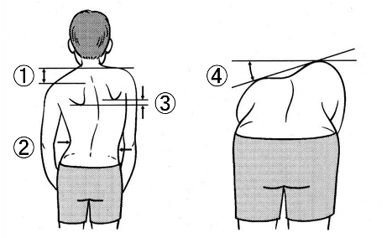 | □①Height of shoulders not equal  □②Waistlines not equal  □③Height of shoulder bones not equal  □④Height of the back not equal when bent forward and raised rib or raised lumbar is observed  （※This item is most important）  □⑤ No problem for ①～④ |  |  |  | (All students are to be examined)  □①No Problem  □②Follow-up・Brief advice＊  □③Orthopedic examination required
Ⅳ．Mark ☑ all that applies to his/her lumbar and extremities  （↓to be answered by parent） |  |  |  |  | (Examination required for students with problems)
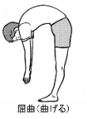  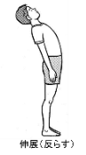  - Feels pain of spine when bent forward or backward? | □①Hurts when bent forward. (since when： )  □②Hurts when bent backward. (since w hen： )  □③Does not hurt either bent forward or  backward. |  |  |  | □①Follow-up・Brief advice＊  □②Orthopedic examination required
- Feels pain when arm or leg is moved?  （Mark ○ on the picture where pain is felt.） | □①Feels pain.  (Since when： )□②No pain. |  |  |  | □①Follow-up・Brief advice＊  □②Orthopedic examination required
- Movement not smooth in some part of arm/leg?  （Mark X on the picture for the applicable part.） | □①Slow movement.  (Since when： )  □②Movement is O.K. |  |  |  | □①Follow-up・Brief advice＊  □②Orthopedic examination required
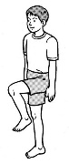  - Cannot stand on  One-leg for over  5 seconds? | □①Cannot stand over 5 seconds.  □②Can stand. |  |  |  | □①Follow-up・Brief advice＊  □②Orthopedic examination required
- Cannot crouch down?  （Keeping one’s full feet flat on the floor） | 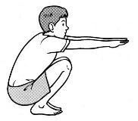  □①Cannot crouch down.  □②Can crouch down. |  |  |  | □①Follow-up・Brief advice＊  □②Orthopedic examination required
School Comments (Nurse, teacher, etc.)  Comment about condition in school or athletic activities, if any. |  | Judgement Name of School Physician  □①Follow-up・Brief advice＊（＊Refer website of “Musculoskeletal Counseling for parent-and-child”）  □②Orthopedic examination  Note（By School Physician）

